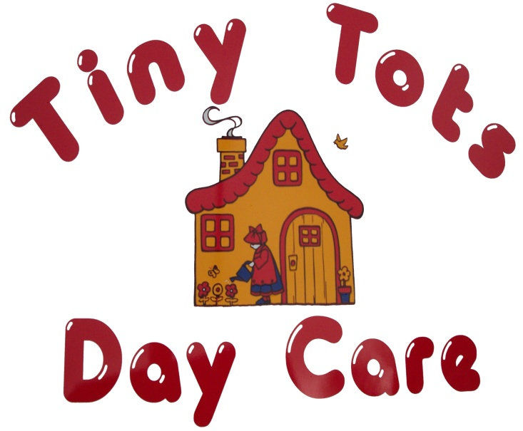

Parents Handbook

Welcome
Tiny Tots Day Care operates within Rossmore School. We share the use of the building with Rossmore who use us for before and after school and also in the school holidays. We work closely with Rossmore School to ensure good relationships and a positive transition for the children.

Contacting us
You can contact the setting by phoning between the hours of 8am and 5pm on 07772529395 or by using the email staff@tinytotsdaycare.co.uk

Settling in
We would recommend that you help your child to settle into the setting by attending some introductory visits. This may involve a few visits, initially with you present, then gradually leaving your child with us for longer time periods. Each child is different, and some children will find it easier to settle into the setting than others. It is therefore important that the introductory period is negotiated individually.

Sessions and Additional sessions
Sessions for children are made on a termly basis. We can only guarantee you the same sessions as your previous term’s booking; if you wish to change the sessions booked we can only accommodate you if there are places available – it is not automatic. Parents are expected to book for the full duration of each term.
If you require a one-off additional session please give at least 24 hours notice, wherever possible we will try to accommodate your needs, but this may not always be possible because of the demand for places. Fees for extra sessions are charged at the usual rate. Tiny Tots is closed on National Bank Holidays
 | Days | Session | Times
Term Time | Monday to Friday | Early Birds | 8am – 8:50am
 |  | Morning | 8:50am – 11:50pm
 |  | Lunch | 11:50pm – 12:50pm
 |  | Afternoon | 12:50pm – 2:50pm
 |  | Night Owls 1 | 3.00pm – 5pm
 |  | Night Owls 2 | 5pm – 6pm
Holiday Time | Monday to Friday | Open except for two weeks at Christmas & two weeks beginning of Summer break. 8am to 5pm

Fees
Please speak to a member of staff for current fees.
As the costs of running the setting increase year on year it is inevitable that the setting’s fees will also increase. Wherever possible these increases will be kept to a minimum.
Information on the collection of fees will be given to you at the beginning of your contracted period. In general, we require two weeks deposit, based on booked sessions, and fees are due weekly in advance.
If your child is absent from the setting on days where sessions have been booked, (whether because of illness, holiday or unplanned changes to arrangements), full fees must still be paid as the setting is unable to recover expenses by offering places to other children.
Setting sessions end promptly. If you are going to be late collecting your child please inform the setting as soon as possible, we reserve the right to impose a late pick-up fee of £5 for each 15 minutes or part thereof on persistently late callers.
In addition, if a child is not collected within 30mins of scheduled pick-up time we may need to contact Social Services. If a parent is under the influence of alcohol or drugs, we also reserve the right to contact Social Services if other named contacts cannot be contacted. We reserve the right to share information with Social Services if requested.

Our Day
We operate a learning through play approach and provide opportunities for all children to be confident, capable and independent. We follow the Early Years Foundation Stage Statutory Guidance which sets out what we need to do to ensure that the environment is safe, suitable and educational. Our ‘Continuous provisions’ (resources that are available everyday) are carefully arranged to ensure that children have the opportunity to progress in all 7 areas of learning and development within the EYFS which are:
Prime Areas:
Personal, Social and Emotional Development
Communication and Language
Physical Development
Specific Areas:
Literacy
Mathematics
Understanding the World
Expressive Arts and Design

For children under 3 years old we focus on the Prime Areas but also recognise the abilities of the child in the other 4 areas. Between the ages of 2 and 3 we are required to write a summary about each child in the Prime Areas of Development, 2-year Check. We will then invite you to discuss this and add ways in which together we can support your child’s development. You can then share this with the Health Visitor when you take your child for the 2-year-old check.

Your child will be assigned a ‘Key Person’. That person will be responsible for helping your child to settle into nursery, helping them with personal care, building an attachment with them and sharing information with yourself. It is also their responsibility to observe, assess and plan for your child’s development.

Children should be brought to the door each session where they will be greeted by a member of staff. In the first few weeks of your child starting this will usually be their Key Person. The Key Person will help your child put their coat and bag on their peg, help them learn where things are, toileting, changing nappies (where applicable), accessing snack and learning our routine and rules. Could we ask when picking up your child that a staff member calls them to the door, this is to ensure that all children are safe.

Throughout the day we work to a timetable that ensures that children are well cared for and all children are offered the same opportunities regardless of whether they attend morning or afternoon sessions.
The daily routine is displayed on the internal walls within the Setting. While certain activities will follow the routine, such as meal times, we like to allow some flexibility in other parts of the routine so that we may respond to events happening around us. However, we loosely adhere to the routine below:
8.00 am Early Birds begins
8:50 Activity on table as children arrive
9.10 Registration
9:15 Smile for a mile
9.30 Small group work
9:40 – 11:00 Free play including rolling snack
11:00- 11:10 Tidy up time/ Nappies
11:10 Phonics
11.15 – 11.45 Large Group Time/Outside Play
11.45 Story time/ Song time / Mindfulness
12.00 Collection & prepare for lunch
12.00 – 13.00 Lunch & quiet time
13.00 Welcome & registration
13.05 Small group work
13:15 Free play including rolling snack
14.15 Tidy up time
14.20 Large Group Time/ Outdoor Play
14.50- 3:00 Story time / song time/ Collection
15.20 Nights Owls session welcome & registration
15.30 Free play & planned activity
16.20 Tidy up
16.30 Snack time
16.40 – 17.00 Free play & collection
17.00 – 18.00 Quiet time & collection

Throughout the day we provide your child with water and/or milk. We also provide regular healthy snacks.

Parent / Carer involvement
Parent meetings are held at least once a term. If you wish to talk about your child’s development, please speak to any member of staff. These will be offered on an appointment basis and will be an opportunity for you to discuss your child’s progress with his/her key worker and to share any thoughts or concerns you may have.
We keep parents as up to date with what is going on in the setting as is possible. We do this by sending out letters, usually sent via School Spider or email, or putting up posters and notices. We also have a private Facebook page which is only available to parent of children attending the setting. On our Facebook page you will find information, and photos, about what the children are doing during the day

Illness, Medicines & Accidents
Children who are ill should not be brought into the Nursery. The day is too demanding for a sick child, and they will be more prone to infections and communicable diseases. Children should also not attend nursery for 48 hours after the last bout of sickness. Also, children should not attend if they have been given Calpol or Nurofen.
We would appreciate it if you could let us know as early as possible when your child will be absent from the setting. It helps us to carry out planned activities better if we are aware of which children will not be attending.
Administration of medicine
We are only able to administer medicines that have been prescribed by your child’s GP. If your child needs medicine while in the setting you will need to complete a medication form at the beginning of each day and to sign it when you collect your child to ensure that you are aware of the medicine given to your child on that day.
If your child has been prescribed antibiotics, they should be absent from the Setting for at least 48 hours.

Accidents
Each member of staff holds a recognised first aid certificate that specialises in care of young children; these are renewed every three years.
Tiny Tots Day Care ‘s number one priority is the safety of your child and although every effort is made to ensure your child is kept safe, accidents do happen. If a child is involved in an accident, emergency first aid treatment will be given, an assessment of the child’s condition made, and an account of the accident and treatment given will be recorded in the accident book.
When you arrive to collect your child, you will be informed of the accident and asked to read and sign the accident book. Should a child be involved in an accident that requires hospital treatment you will be informed immediately, and arrangements made to meet you at the hospital. In all instances where it is felt necessary to take a child to hospital an ambulance will be called. Please inform the setting’s staff if your child has had an accident at home.

Policies & procedures
As part of the registration process, we are required to prepare a number of policies for the smooth running of the Nursery.

A complete set of policies is available for you to read and includes:
- Safeguarding Children and Child Protection
- Online Safety
- Promoting British Values
- Prevent Duty and Radicalisation
- Intimate Care
- Whistleblowing
- Mobile phone and electronic device use
- Inclusion and Equality
- Special Educational Needs and Disabilities (SEND)
- Looked After Children
- Dealing with Discriminatory Behaviour
- Sickness and Illness
- Medication
- Promoting positive Behaviour
- Complaints and Compliments
- Visits and Outings
- Lost Child in Nursery
- No Smoking
- Data Protection and Confidentiality
- Parents and Carers as Partners
- Late Collection and Non- Collection
- Key worker policy
- Settling in policy

Our policies are intended to act as guidelines for good practice and are in place to ensure the wellbeing of the children. However, they are considered to be working documents and as such are subject to change to meet the demands of changing conditions or attitudes.

The Staff
Tiny Tots staff work together to provide the very best in childcare.
A complete list of staff members, their relevant qualifications and special areas of responsibility can be found below:
Name | Position | Qualifications
Clare | Manager/ Safeguarding Lead | NVQ 2 and 3 Supporting Teaching and learning in Schools.  Level 3 Diploma of the Children and Young People’s Workforce  First Aid  Food Hygiene  Child Protection  Working with children and young people with special needs  Level 3 Safeguarding
Gemma | Deputy Manager | NVQ2 and 3 Supporting Teaching and learning in Schools.  Level 3 Diploma of the Children and Young People’s Workforce  First Aid  Food Hygiene  Child Protection  Level 2 Certificate in Principles of Working with Individuals with Learning Difficulties
Maria | Nursery Assistant/ SENDCO | Level 3 Diploma Supporting Teaching and learning in Schools.  First Aid  Child Protection  Food Hygiene  Level 3 SENDCO Training
Steph | Nursery Assistant | Level 2 Award in Support Work in Schools and colleges  First Aid  Child Protection  Food Hygiene
Bianka | Nursery Assistant | Level 2 Teaching Assistant  Autism Training  Child Protection  Food Hygiene
Issy | Nursery Assistant | Level 2 Childcare  Safeguarding Awareness
Staff continuously develop their knowledge by completing relevant courses

